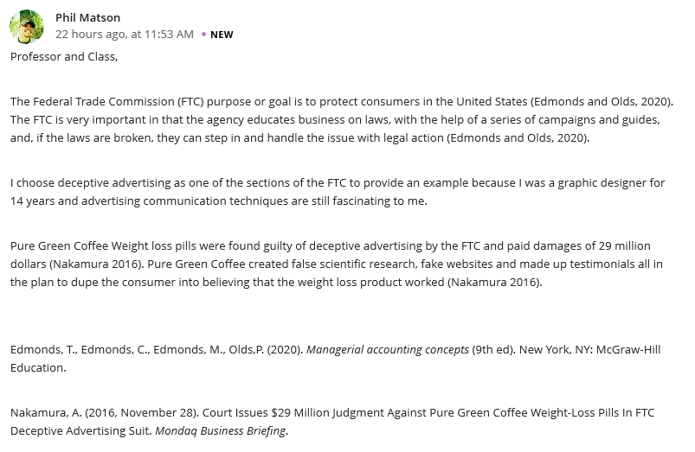
Reply
I strongly agree that the sole purpose of the Federal Trade Commission is protecting the consumers in the US soil since the agency plays a vital role of offering education in relation to business laws. In fact, a series of campaigns and guides facilitate the intended awareness. Well, I also consider deceptive advertising section in mobilizing the consumers due to your long experience in graphic designing as well as massive skills in advertising communication which can pivot the process. Still on the same, FTC utilized deceptive advertising especially on Pure Green Coffee Weight which compensated a damage worth 29 million dollars because they were found guilty. The reason behind, Pure Green Coffee broke the business laws by creating false scientific research, fake websites and developed testimonials that compromised the consumer’s mindset to believe that the weight loss commodity performed as expected.
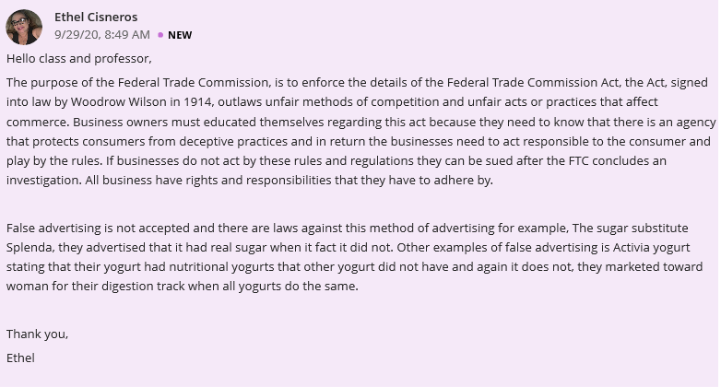
Reply
It has come into my attention that the important purpose of the FTC is enforcing the finer details of the Federal Trade Commission Act that came into practice in 1914 facilitated by Woodrow Wilson based on the way you have clearly and precisely elaborated. By expansion, the act protects the consumers against unscrupulous business owners who indulge in unfair competitive methods including unfair practices that influence business endeavors. To be on the safer side, business owners are called upon to gain additional knowledge concerning the act in bringing light to them that there is an agency, particularly, the FTC that provide an avenue where consumers can file their claims in regards to the specific product, thus, protecting their interest. Additionally, business owners should avoid false advertising because it is against the business laws and the entities who involve themselves in this act can pay a huge fine, for instance, the sugar substitute Splenda and Activia yogurt. I support your argument because it elevates an amicable environment that is suitable for the commerce when it is instituted by business owners.

